**ELECTRONIC MAIL AND SMTP**

Look at the scenario below, where Alice sends an email to Bob.

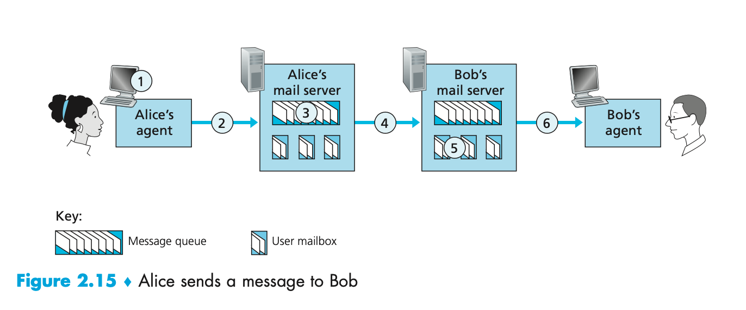

For the questions below, assume both Bob's and Alice's user agents use the HTTP protocol.

**QUESTION LIST**

1. At point 2 in the diagram, what protocol is being used?  
  
2. At point 4 in the diagram, what protocol is being used?  
  
3. At point 6 in the diagram, what protocol is being used?  
  
4. Does SMTP use TCP or UDP?  
  
5. Is SMTP a 'push' or 'pull' protocol?  
  
6. Is HTTP a 'push' or 'pull' protocol?  
  
7. What port does SMTP use?  
  
8. What port does HTTP use?